**SYEDA FATIMA SHAH**

**20th March 2023**

***Task # 1:***

**-Download and attach Northwind database into your SSMS. We will use this dataset for practicing SQL.**

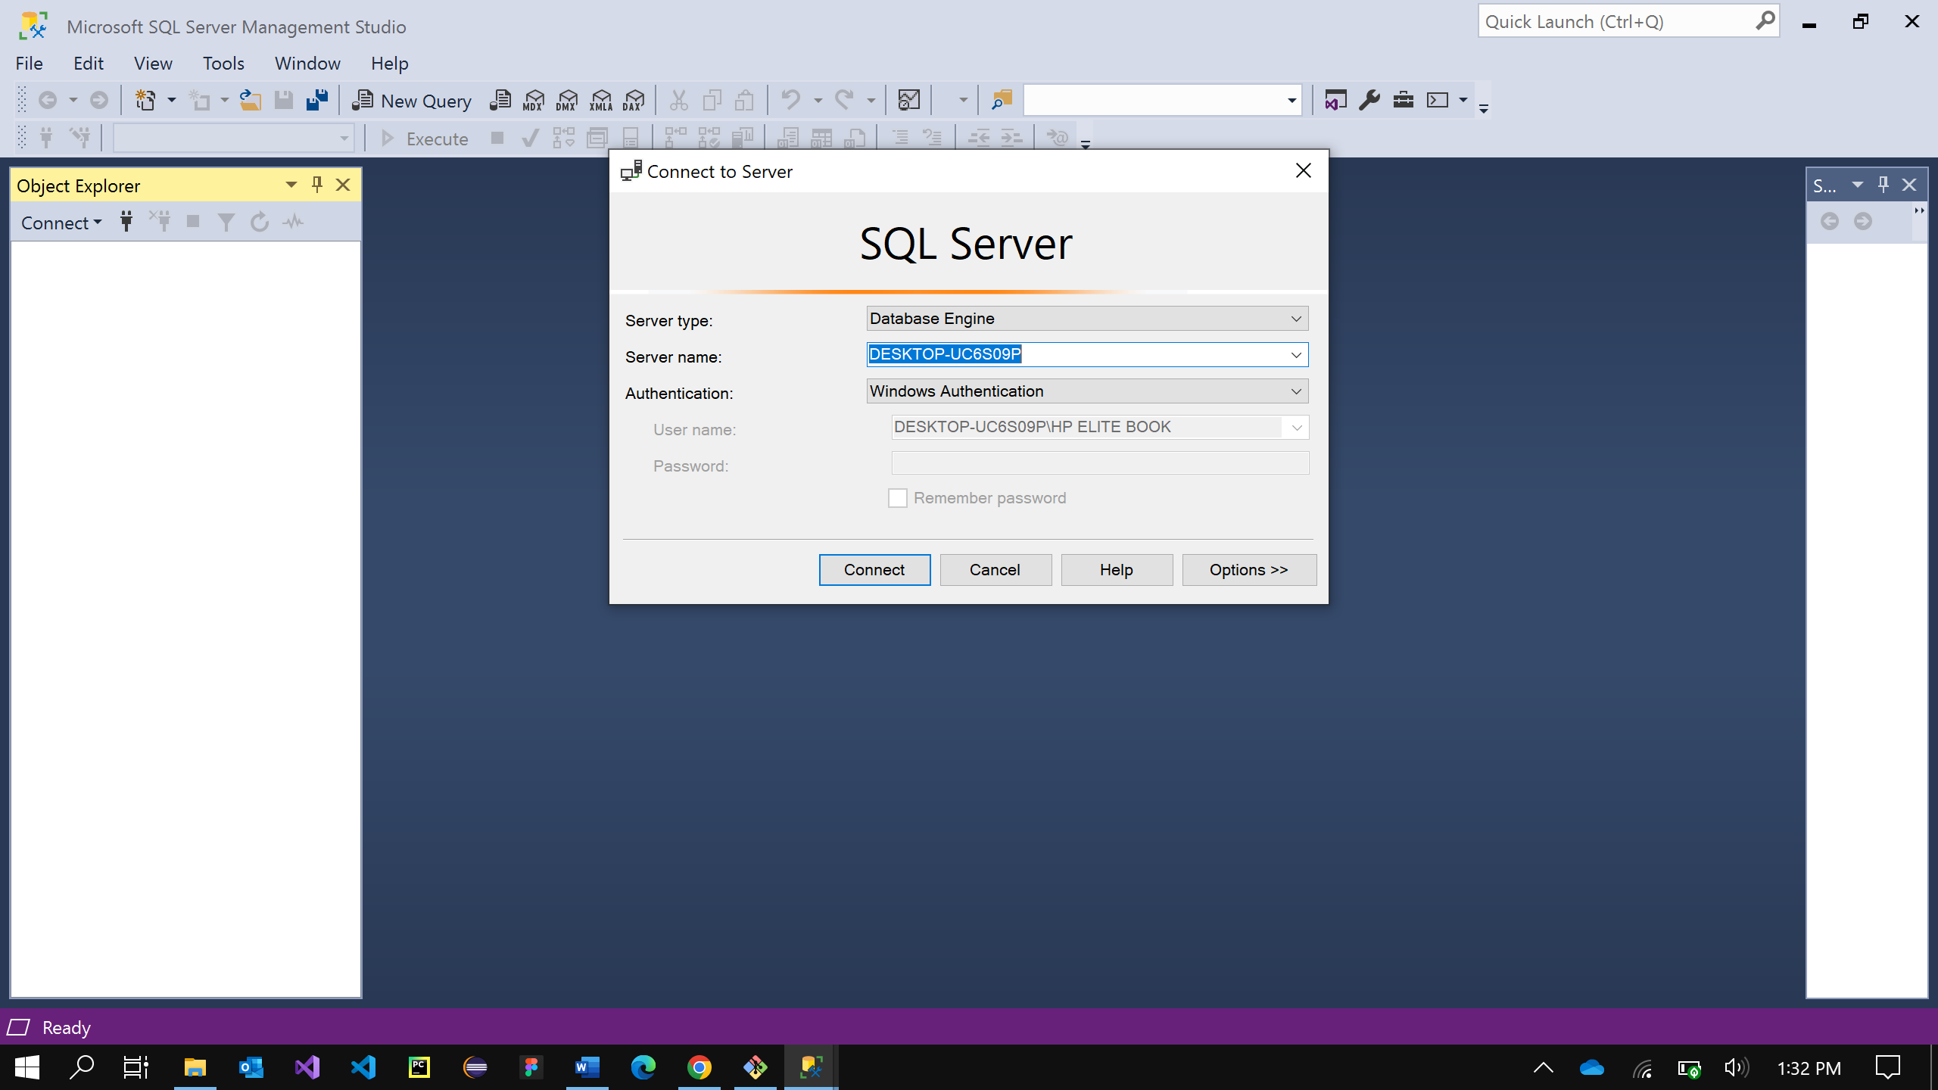

***Task # 2:***

**Fork this repo and add a folder with you name in it. then create a PR.**

**Repo Link:**

[**https://github.com/ahti-mughal/BWT_DE_Repository.git**](https://github.com/ahti-mughal/BWT_DE_Repository.git)

**How to add a fork to repo:**

[**https://docs.github.com/en/get-started/quickstart/fork-a-repo**](https://docs.github.com/en/get-started/quickstart/fork-a-repo)

**How to create a Pull request PR:**

[**https://docs.github.com/en/pull-requests/collaborating-with-pull-requests/proposing-changes-to-your-work-with-pull-requests/creating-a-pull-request-from-a-fork**](https://docs.github.com/en/pull-requests/collaborating-with-pull-requests/proposing-changes-to-your-work-with-pull-requests/creating-a-pull-request-from-a-fork)

**--SQL Server SEtup + DB Setup + Github Repo Setup**

DONE